Round -1 Load testing

Total Message on Source Historical topic =1,316,020

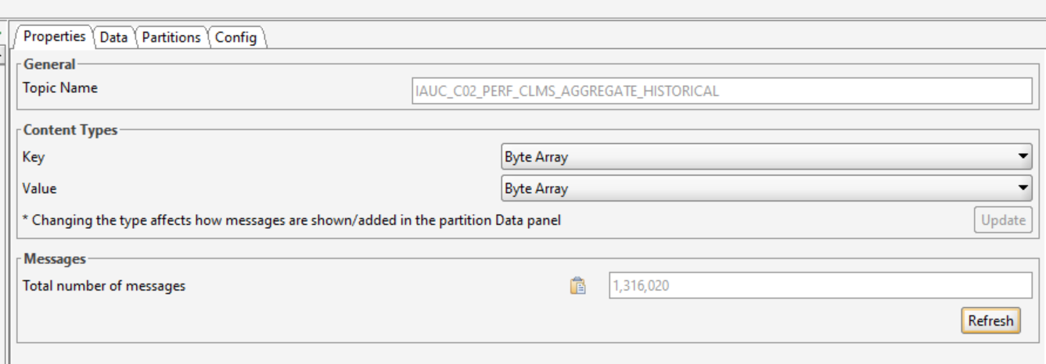

Production of messages Start Time- 10:04

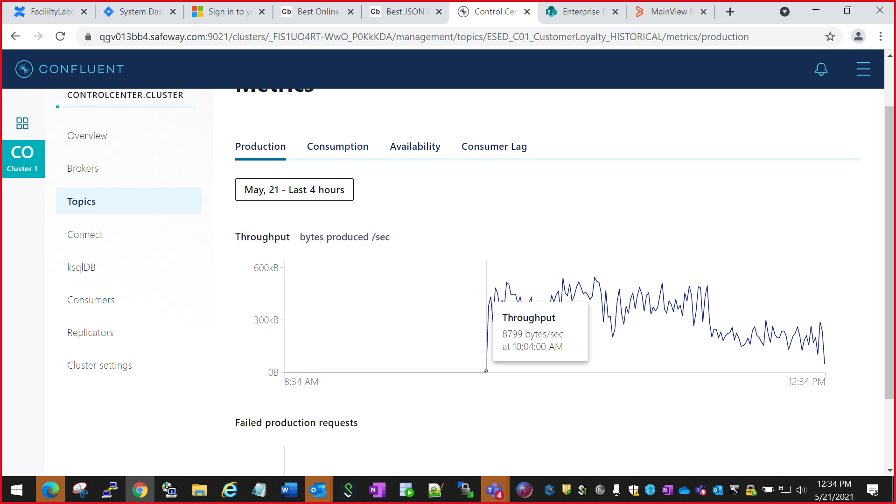

End time- 1:09 pm

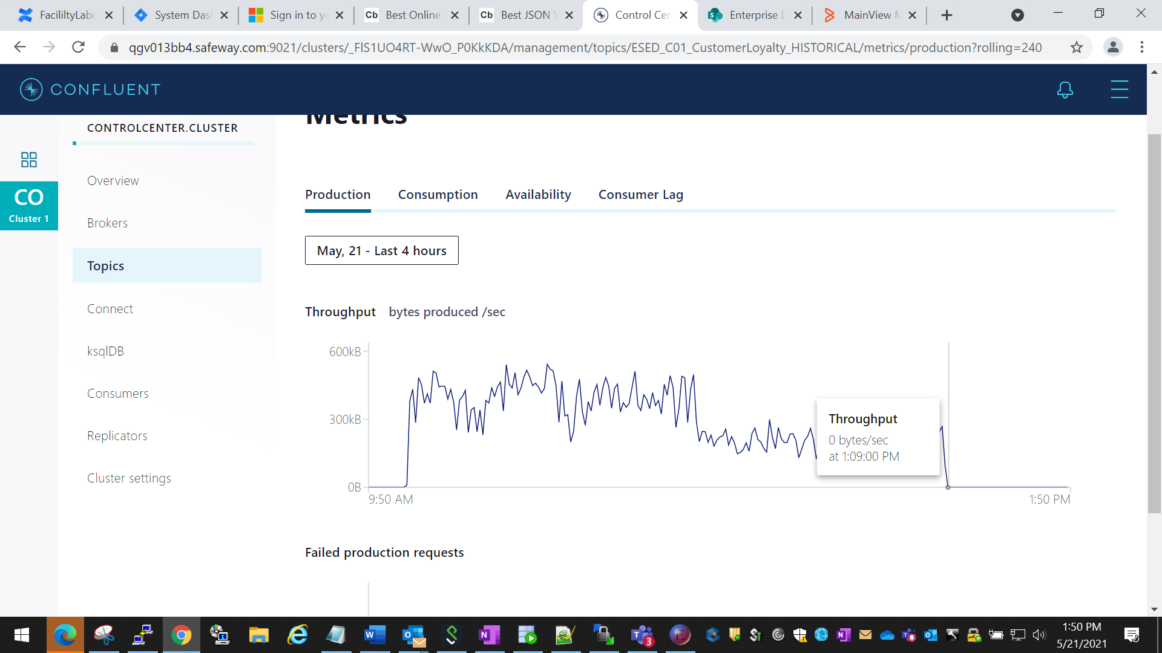

Total Message on the Historical topic- 1,316,029

ESED_C01_CustomerLoyalty_HISTORICAL

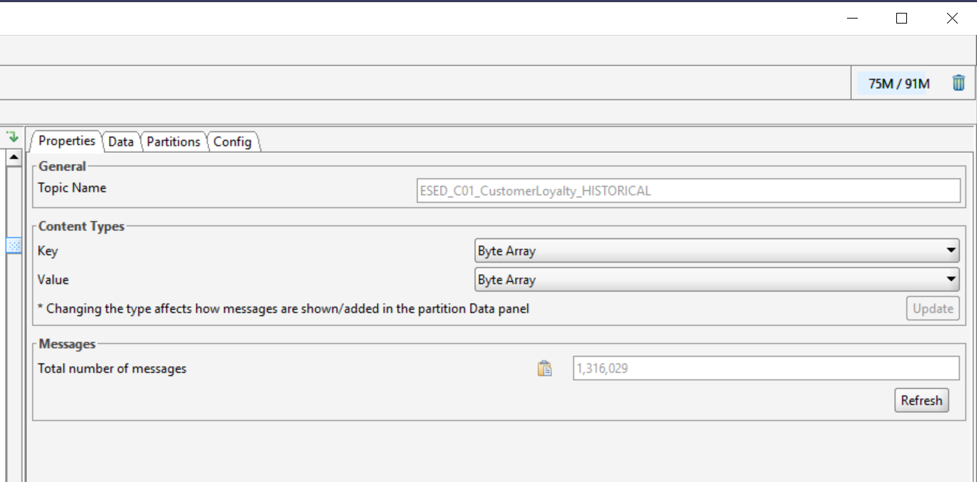

Total time taken in consumption of message = 3 Hours and 13 mins

**Round -2** Load testing after EDIS made the changes from 3 instance to 7 Instances on IIB Broker for

For ESED_C01_CustomerLoyalty_HISTORICAL

Production Start time- 2:49:00pm

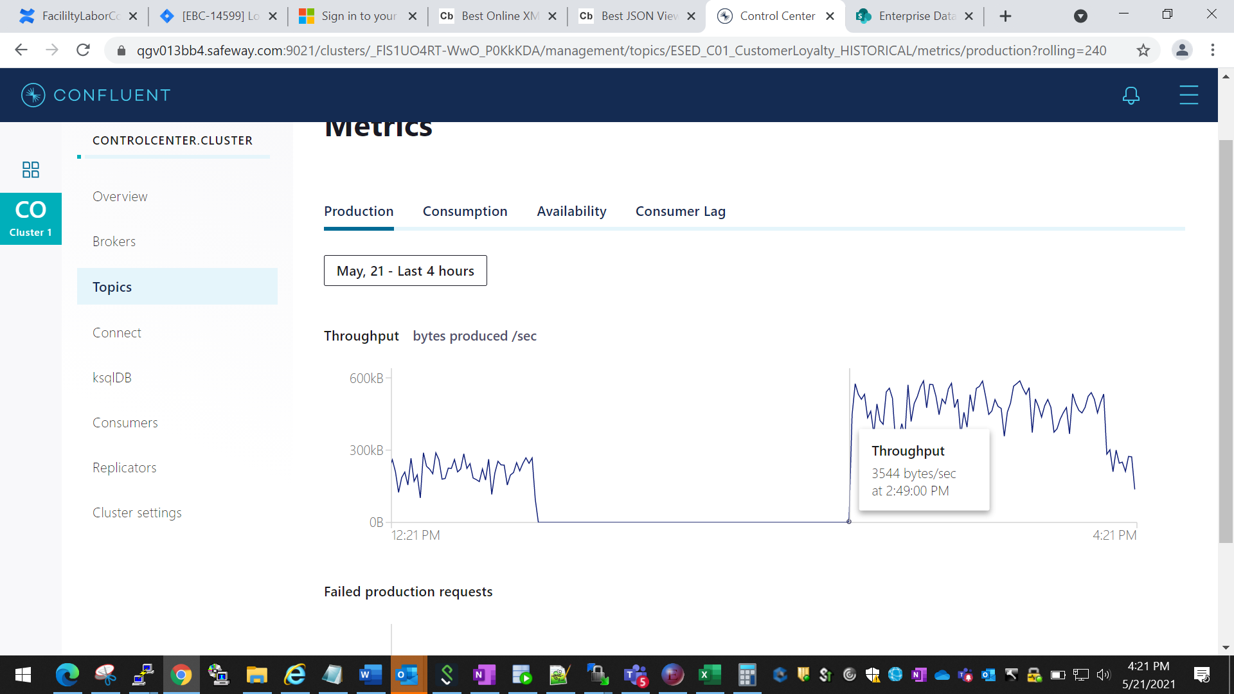

End Time- 5:20 Pm

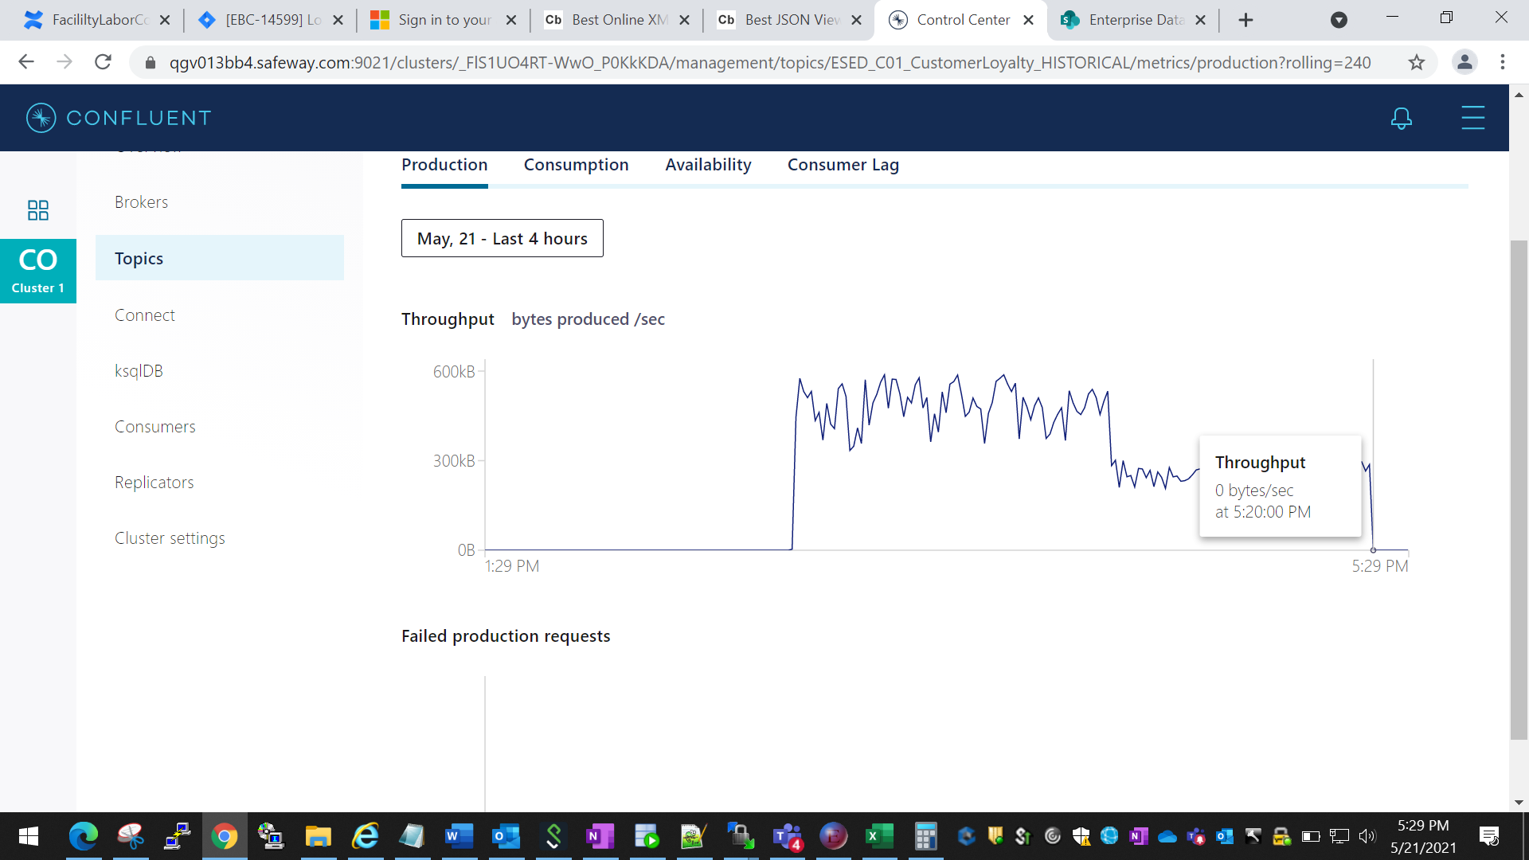

-

Total Message on Topic-

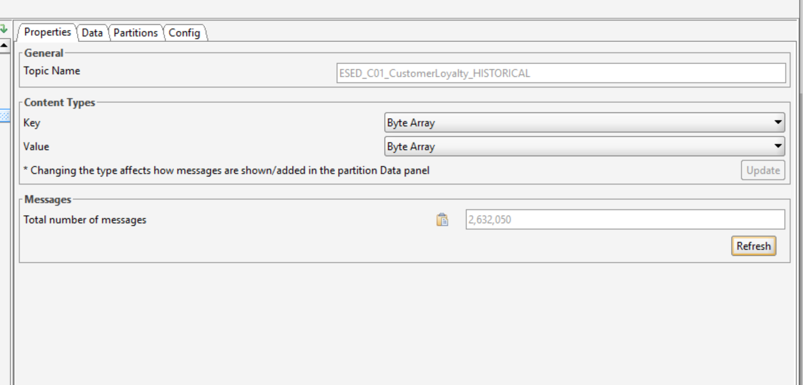

Old message count on topic, before started the consumption again-



Total No of new message consumed on topic- 1,316,021

**Total time taken in consumption of new message = 2 hours 31 mins**